Chapter 17, Solution 47.

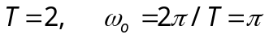
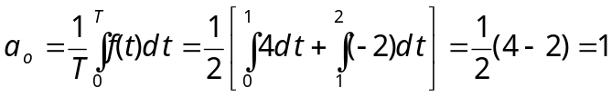
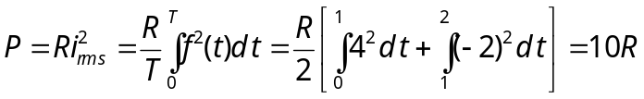

The average power dissipation caused by the dc component is



